LAB 4
Measurements with the oscilloscope
PRE-LAB Exercises.
PRELAB4-1.- Estimate the theoretical rise time (between 10% and 90%) of the oscilloscope in the lab (BW=60MHz).
The theoretical rise time is considered in the industry to be:
$$t_{r}=\frac{0.35}{BW}=\frac{0.35}{60×{10}^{6}}=5.83×{10}^{-9}s=5.83 ns$$
$$t_{2,total}=\sqrt{t_{2}^{2}+t_{2 cable}^{2}}=\sqrt{{(5.83 ns)}^{2}+{(12.6 ns)}^{2}}=13.883 ns$$
PRELAB4-2.- Estimate the input impedance of the oscilloscope with a coaxial cable of 1 m at 10 kHz and 10 MHz (Rin=1 MΩ, Cin=15 pF, Ccoax(l)=100 pF/m).
$$C_{t}=C_{c}//C_{in}=C_{c}+C_{in}=15pF+100pF =115 pF$$
$$Z_{in}=Z_{1}+Z_{2}$$
$$Z_{1}=impedance relative to the oscilloscope probe=R_{p} // \frac{1}{sC_{p}}$$
$$Z_{2}=\frac{1}{sC_{t}}//R_{in}$$
If there is no probe: $Z_{in}=Z_{2}=\frac{1}{sC_{t}} // R_{in}=\frac{R_{in}}{1+R_{in}sC_{t}}$
$$s=jω=j×62.8×{10}^{3}$$
For 10 kHz:
$$w=2πf=2×π×10×{10}^{3}=62.8×{10}^{3} rad/s$$
$$Z_{in}=\frac{{10}^{6}}{1+\left({10}^{6}×115×{10}^{-12}×62.8×{10}^{3}j\right)}=\frac{{10}^{6}}{1+7.222j}=\frac{{10}^{6}×(1-7.222j)}{1+52.157}=\left(18812.097-135860.967j\right)Ω$$
$$\left|Z_{in}\right|=137157.2 Ω=137.157kΩ$$
For 10 MHz:
$$w=2πf=2×π×10×{10}^{6}=62.8×{10}^{6} rad/s$$
$$Z_{in}=\frac{{10}^{6}}{1+\left({10}^{6}×115×{10}^{-12}×62.8×{10}^{6}j\right)}=\frac{{10}^{6}}{1+7.222×{10}^{3}j}=\frac{{10}^{6}×(1-7.222×{10}^{3}j)}{1+52.157×{10}^{6}}=\left(0.0192-138.466j\right)Ω$$
$$\left|Z_{in}\right|=138.47 Ω$$
PRELAB4-3.-If we use an attenuating probe x10, what is the input impedance at the tip of the probe? (Suppose a coaxial cable for the probe with similar characteristics)

$$C_{t}=C_{in}+C_{c}$$
For low frequencies:
$$V_{o}=V_{g}×\frac{R_{in}}{R_{in}+R_{p}+R_{out}}=\frac{1}{10}→ R_{p}=9R_{in}$$
$$Z_{in}≅10MΩ$$
For high frequencies:
$$V_{o}=V_{g}×\frac{c_{p}}{C_{p}+\left(C_{in}+C_{c}\right)}$$
$$C_{p}≅\frac{C_{c}+C_{in}}{10} C_{c}+C_{in}=10C_{p}$$
$$Z_{in}=\frac{1}{j×2×π×f×\left(\frac{C_{c}+C_{in}}{10}\right)}$$
For the case of the probe:
$$Z_{in, probe}=10 MΩ //\frac{1}{j×ω×2×f×\left(\frac{C_{in}+C_{p}}{10}\right)}≈10Z_{in}$$
If the coax cable of the probe has the same characteristics of the coax cable, then:
$$R_{p}×C_{p}=C_{t}×R_{s}→\frac{V_{s}}{V_{in}}=\frac{R_{s}}{R_{s}+R_{p}}=\frac{1}{10} that is the probe atenuation x10$$
$$R_{s}+R_{p}=Z_{in}=R_{s}×10=1MΩ×10=10 MΩ$$
PRELAB4-4.- Estimate the measured rise time when connecting a 10 kHz square signal, with an output impedance of 1 kΩ, to the oscilloscope using a coaxial cable similar to PRELAB4-2.
From the information in Atenea:
$$t_{r}=\ln\left(9\right)×R_{out}×\left(C_{in}+C_{coax}\right)=\ln\left(9\right)×{10}^{6}×\left({15×10}^{-12}+{100×10}^{-12}\right)=252.68 us$$
PRELAB4-5. What will be the result for PRELAB4-4 if we use an attenuating probe x10?
$$t_{r}=\ln\left(9\right)×Z_{in probe}×\left(C_{in}+C_{coax}\right)=\ln\left(9\right)×10×{10}^{6}×\left({15×10}^{-12}+{100×10}^{-12}\right)=2.52 ms$$
PRELAB4-6. From the specifications of the function generator calculate the standard uncertainty of the amplitude of a 1 V (peak) sinusoidal signal of 1 kHz.
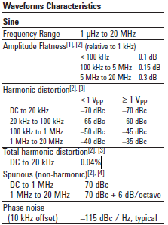
This is the information that we get from the data sheet.
The amplitude flatness for a f < 100 KHz = 0.1dB, to dBV
$$0.1 dBV=20\log\left(V\right)→V=1.011579V$$
To calculate the amplitude uncertainty:
$$Accuracy= ±\left(1\%·1V±1m V_{pp}\right)·1.011579=11.127mV$$
$$Uncertanty =\frac{μ}{k}=\frac{11.127}{\sqrt{3}}=6.424mV$$
PRELAB4-7. Calculate the standard uncertainty of the oscilloscope when measuring the amplitude and rms value of the previous signal. Take into account the oscilloscope noise.
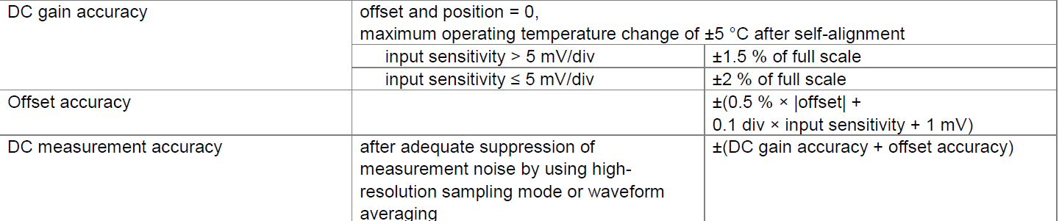
$${Uncertainty}_{amplitude}=\frac{{1V}_{pp}×\frac{1.5}{100}+0.1 div×\frac{5 mV}{div}+1 mV}{\sqrt{3}}=9.526 mV$$
We know that $V_{rms}=\frac{V_{pp}}{2CF};CF=\sqrt{2}$
$${Uncertainty}_{Vrms}=\frac{\frac{{1V}_{pp}}{2\sqrt{2}}×\frac{1.5}{100}+0.1 div×\frac{5 mV}{div}+1 mV}{\sqrt{3}}=3.928 mV$$
LAB exercises
LAB4-1.- Connect the function generator, and select a 2 V peak to peak amplitude, 1 Hz sinus signal. Connect the output of the function generator to the oscilloscope and set the controls to see 1 signal cycle. You must see the signal amplitude as big as possible on the oscilloscope screen. The oscilloscope must be coupled in DC and the trigger must be in the NORMAL position. Do not use the Auto-scale button!!

Measure the peak to peak amplitude of the signal on the screen.

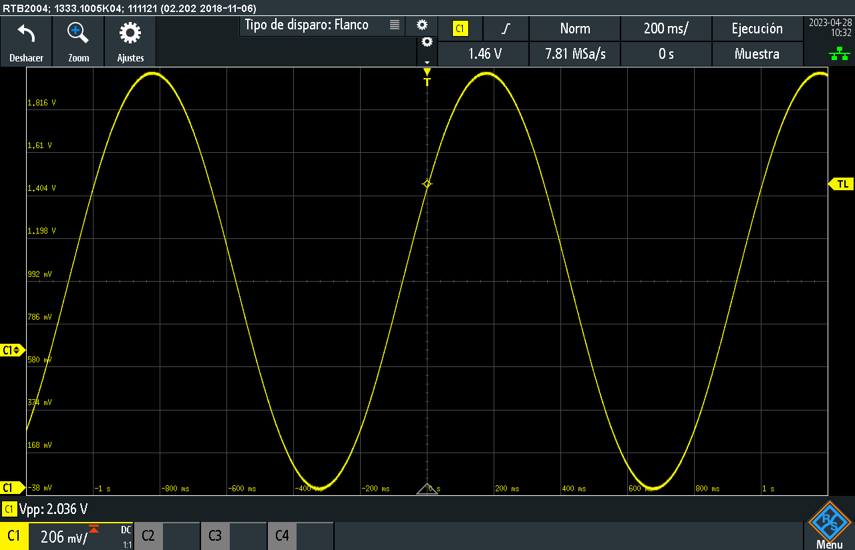
The peak-to-peak amplitude of the signal is: Vpp=2.036V
LAB4-2.- Change the configuration of the vertical channel of the oscilloscope to AC coupling.
Measure the peak to peak amplitude of the signal on the screen
The peak-to-peak amplitude of the signal is:Vpp =1.0912V
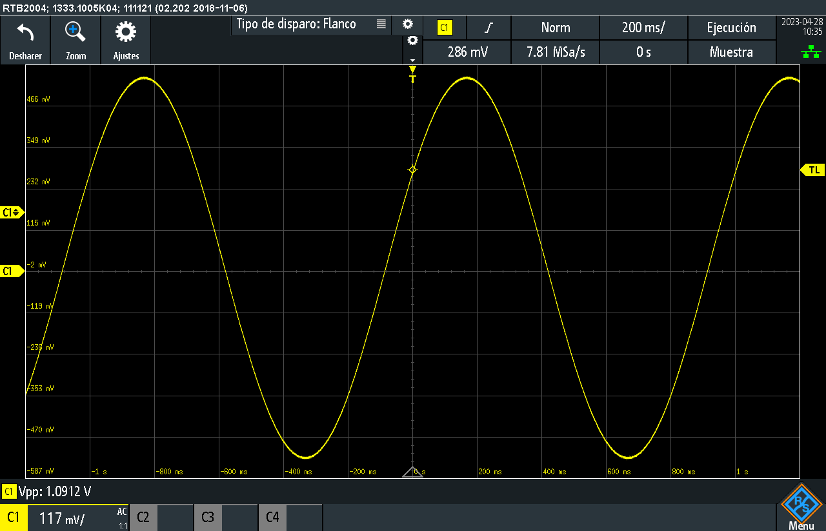
Is there any difference between the two measurements? What is the reason?
Yes, there is a difference between the two measurements due to the AC coupling that attenuates the low frequencies signals.
LAB4-3.- Now, connect the function generator to the oscilloscope with an attenuation probe (x10) leave the coupling to AC.
Measure the peak to peak amplitude of the signal on the screen
Is there any difference with the previous measurements?

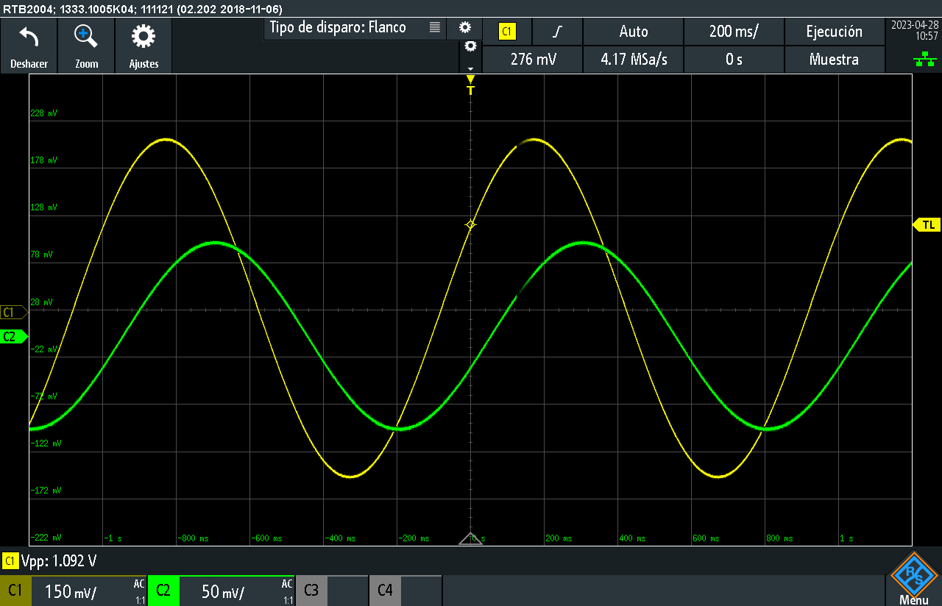
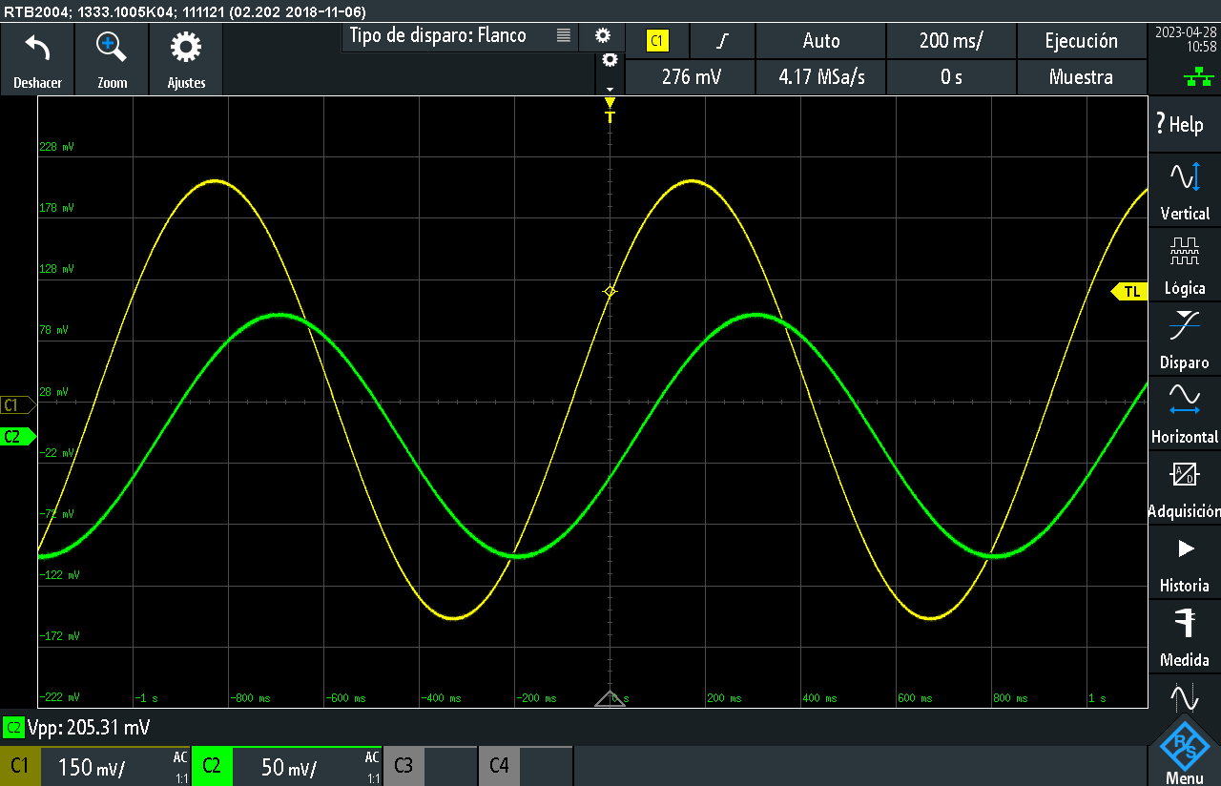
The channel 1 is connected to the function generator and the channel 2 is connected to the probe. The peak-to-peak amplitude of the signal is Vpp = 205.31 mV
Is there any difference with the previous measurements? What is the reason?
Yes, there is the difference because the probe attenuates the signal. Since the probe used provides a x10 attenuation the resulting peak to peak voltage is 1/10 of the previous exercise.

LAB4-4.- Change the oscilloscope coupling to DC. Set the frequency of the function generator to 10 kHz and select a square waveform. Connect the function generator to the oscilloscope with a coaxial cable. Change the timebase of the oscilloscope to 20 ns/div and configure the trigger to a positive slope in the middle of the screen.
Measure the rise time between 10% and 90% of the displayed signal (note: you can use the automatic measurement function of the oscilloscope)
The automatic rise time measurement gives more or less $t_{r}=7ns$
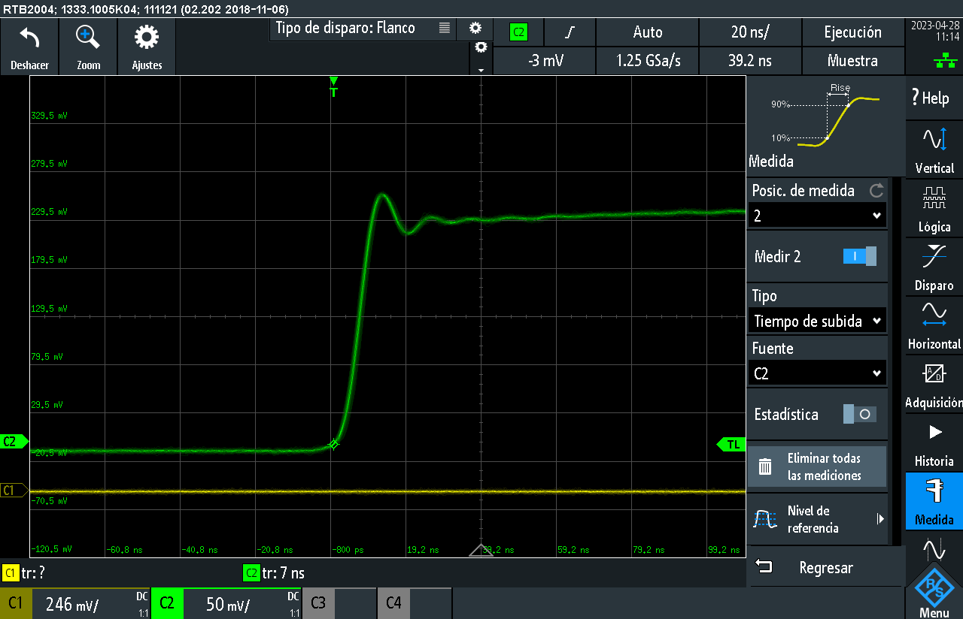
Is there any difference with the calculated values in the PRELAB 3-1?
In the prelab calculations we used an output resistance of 1 kHz, and the resulting rise time was:
$$t_{r,meas}= R_{out} \left(C_{in}+C_{coax}\right)lnln \left(9\right) ={10}^{3}⋅lnln \left(9\right) ⋅115⋅{10}^{-12}= 252.681 ns$$
In the lab, the output resistance is 50 Ohm and consequently the rise time is:
$$t_{r,meas}= R_{out} \left(C_{in}+C_{coax}\right)lnln \left(9\right) =50⋅lnln \left(9\right) ⋅115⋅{10}^{-12}= 12.634 ns$$
$$t_{r,osc}=\frac{0.35}{BW}=\frac{0.35}{60⋅{10}^{6}}=5.83 ns$$
$$t_{r,total}=\sqrt{t_{r,meas }^{2}-t_{r,osc}^{2}}= \sqrt{{\left(12.634⋅{10}^{-9}\right)}^{2}-{\left(5.83⋅{10}^{-9}\right)}^{2}} =11.208 ns$$
The two results are compatible (7 ns and 11.208 ns).
LAB4-5.- Connect the function generator to the oscilloscope using a 1 kΩ resistor in series with the signal and coaxial cable. Measure again the rise time between 10% and 90% of the displayed signal. Is there any difference with the measured value with the previous measurement? What is the reason?
With the probe at x1:
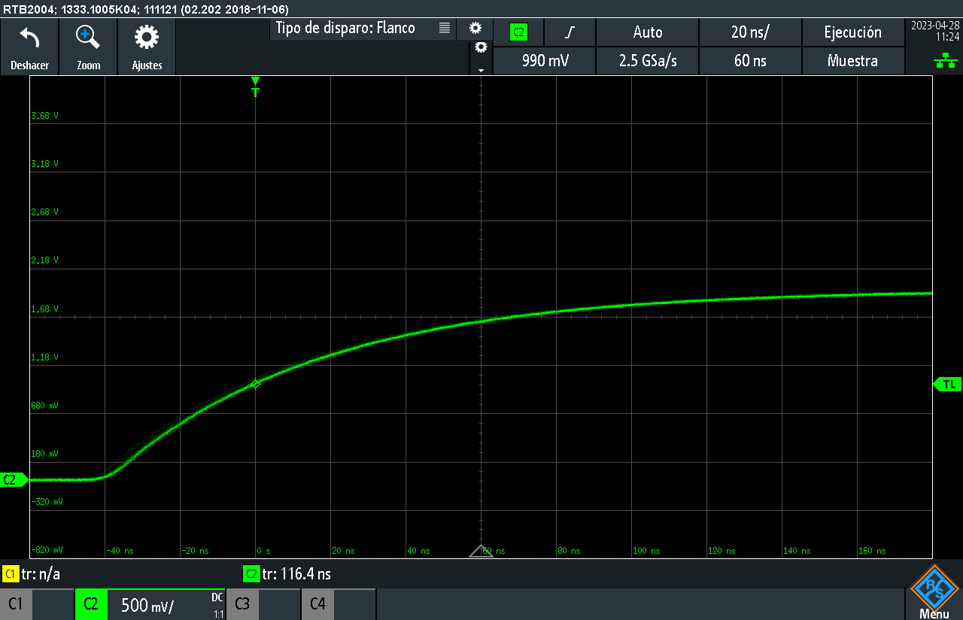
Estimate the equivalent cable capacitance from the measured rise time.
$$t_{r,meas}=116.4 ns$$
$$t_{r}= \sqrt{t_{r, meas }^{2}-t_{r,osc}^{2}} = \sqrt{{\left(123⋅{10}^{-9}\right)}^{2}-{\left(5.83⋅{10}^{-9}\right)}^{2}}=122.862 ns$$

Estimate the equivalent cable capacitance from the measured rise time.
$$C_{eq}=C_{in}+C_{coax}$$
$$t_{r}=\left(50+{10}^{3}\right)⋅\left(C_{in}+C_{coax}\right)lnln \left(9\right)$$
$$C_{eq}=\frac{t_{r}}{lnln \left(9\right) ⋅\left(50+{10}^{3}\right)}=\frac{116.4⋅10^{-9}}{1050⋅lnln \left(9\right) }=50.453 pF$$
LAB4-6.- Replace the coaxial cable from the previous setup with a attenuating probe. Measure again the rise time between 10% and 90% of the displayed signal.
Is there any difference with the measured value with the previous measurement? What is the reason?

With the probe at x10:
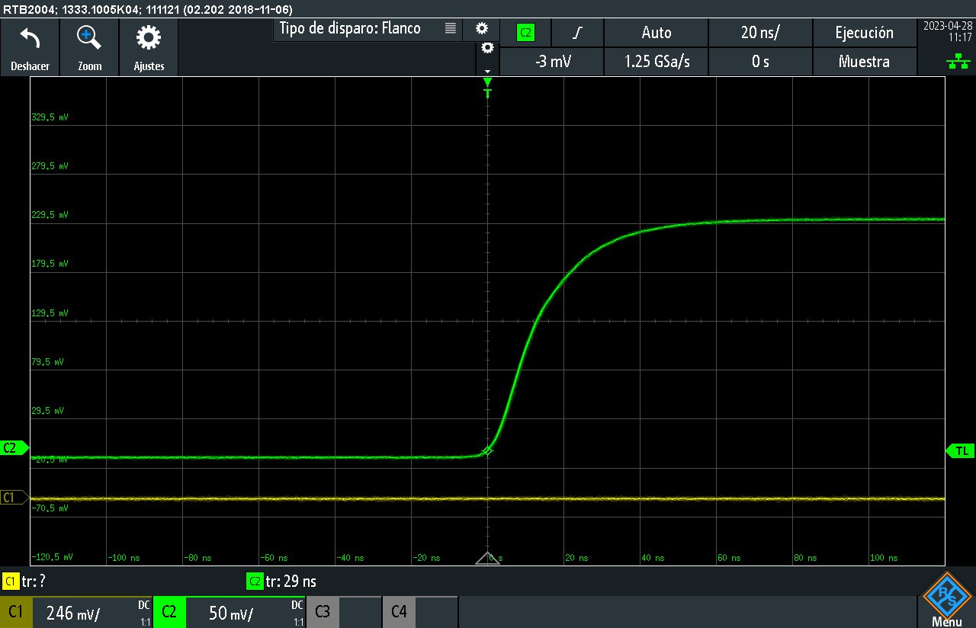
Estimate the equivalent input capacitance of the probe from the measured rise time.
$$t_{r,meas}=29 ns$$
$$t_{r}= \sqrt{t_{r, meas }^{2}-t_{r,osc}^{2}} = \sqrt{{\left(29⋅{10}^{-9}\right)}^{2}-{\left(5.83⋅{10}^{-9}\right)}^{2}}=28.408 ns$$
Estimate the equivalent input capacitance of the probe from the measured rise time.
$C_{eq}=\frac{t_{r}}{0.35⋅2π⋅\left(50+{10}^{3}\right)}=\frac{28.408⋅10^{-9}}{1050⋅lnln \left(9\right) }=12.31 pF$
Now we are going to evaluate the effect of the noise in the automatic measurements of amplitude and time that can be made with the oscilloscope. To simplify the procedure or recording the data you can use the example program in LabView provided by the teacher.
Connect the function generator, and select a 100 mV peak to peak amplitude, 50 mV DC offset, 1 kHz sinus signal. Connect the output of the function generator to the oscilloscope and set the controls to see 1 signal cycle. You must see the signal amplitude as big as possible in the oscilloscope screen. The oscilloscope must be coupled in DC and the trigger must be in the AUTO
Voltage measurements
LAB4-7.- Configure the oscilloscope with the LabView program to measure the peak to peak voltage. Modify the program to take 100 measures and calculate the average value and standard deviation.
What is the standard uncertainty of the measurement due to the noise?
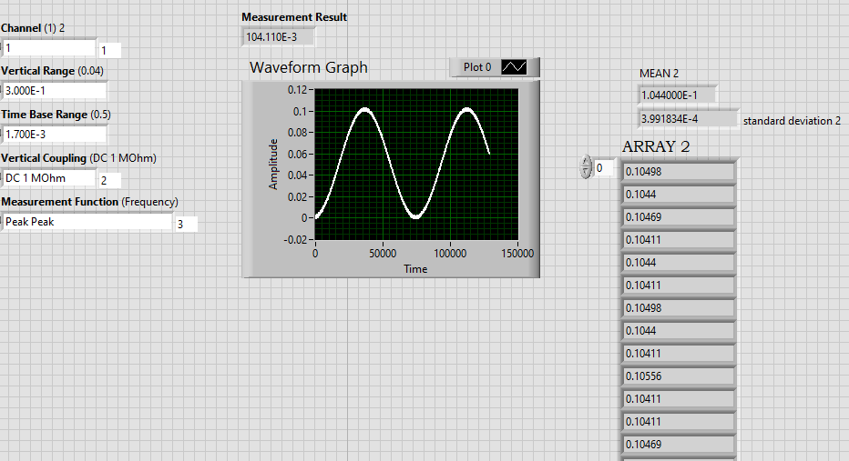
When we ask for peak to peak there is a lot of noise in the measurement. We have a lot of probability to have values bigger than sigma. The measurement will be contaminated by the noise in a very big percentage.
Repeat the 100 measures activating the averaging in the oscilloscope (16 averages are enough)
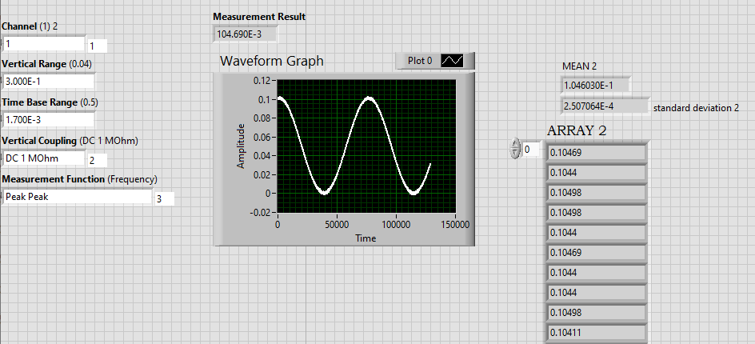
Averaging 16 times we see that the standard deviation is half of the value before.
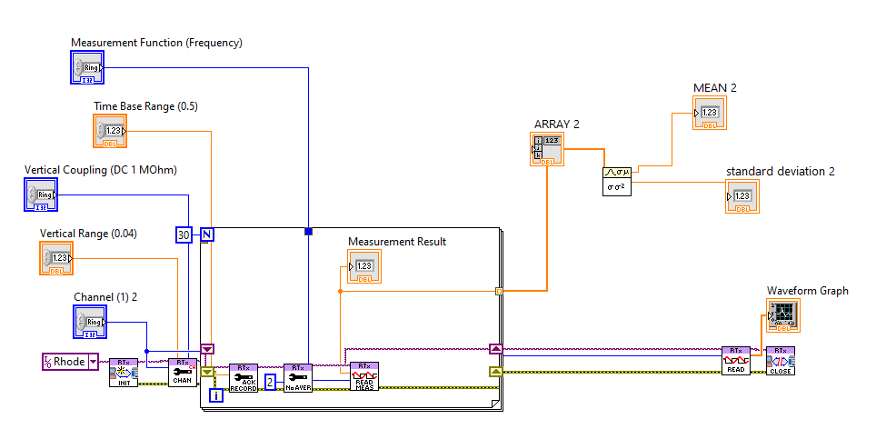
Is there any difference with the previous results?
Sinconous averaging is the one that the oscilloscope uses for the reduction of the noise $sigma_{n_{N}}=sigma_{M}/root(N)$

What is the reason?

Explicación gaussian noise cancellation

LAB4-8.- Repeat the same procedure form LAB3-7 with the RMS value.
What is the standard uncertainty of the measure due to the noise?
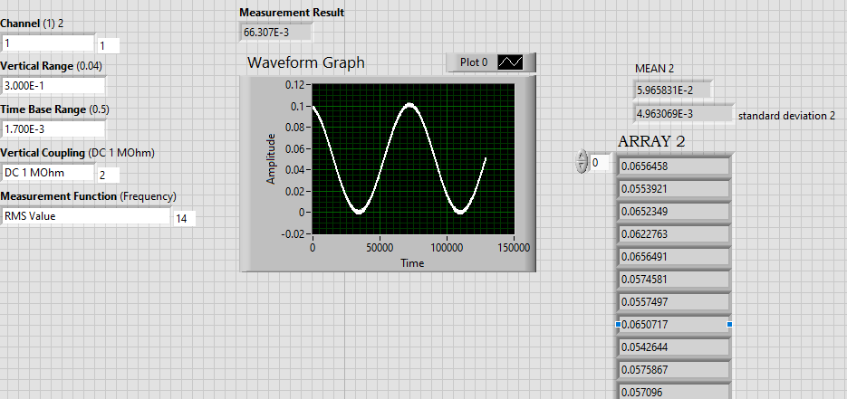

Repeat the 100 measures activating the averaging in the oscilloscope (16 averages is enough)
Is there any difference with the previous results?

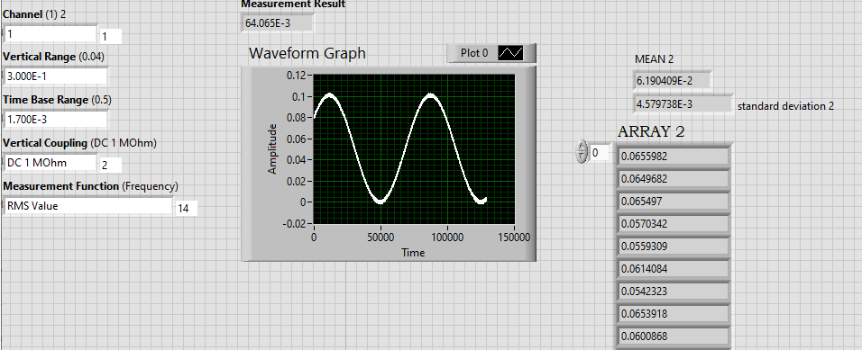

Time measurements

LAB4-9.- Configure the oscilloscope with the LabView program to measure the period of the input signal. Modify the program to take 100 measures and calculate the average value and standard deviation.
What is the standard uncertainty of the measure due to the noise?

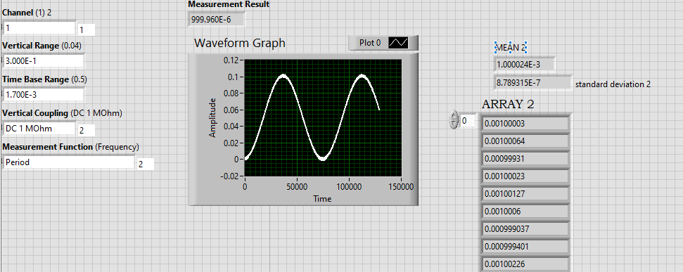

LAB4-10.- Change the amplitude of the function generator to 1,5 V peak to peak. Repeat the measurements of LAB4-9.
What is the standard uncertainty of the measure due to the noise? Is the mean value in agreement with function generator specifications?

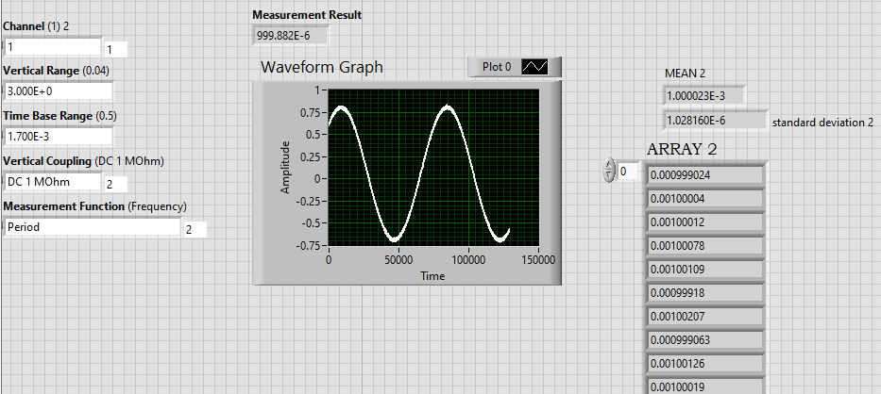
Is there any difference with the previous results?
We have a different standard deviation, this time the result is bigger than with the 100mV peak to peak
What is the reason?
We think this difference is due to the higher range that the signal has with 1.5V, there is more amplitude and therefore the deviation can be bigger because of the noise. As the period is calculated using the inclination, as the inclination is bigger with 1.5V the standard deviation is smaller than with less voltage because then the inclination is smaller.

